**Practical 1:**

**Aim:** To create a simple sequential model using Keras.

**Observations:**

1. When the sequential model was fitted on the random data generated using numpy, the accuracy was 0.5040. When a layer was added, the accuracy increased to 0.5200.
2. In Exercise 1: when the number of epochs was increased to 100 and two more layers with activation=’relu’ were added, the accuracy become 1.
3. For the mnist dataset, there were 512,256,1 nodes respectively in layers 1,2,3. The accuracy obtained on running the model was 0.9808.
4. Model summary was as follows:

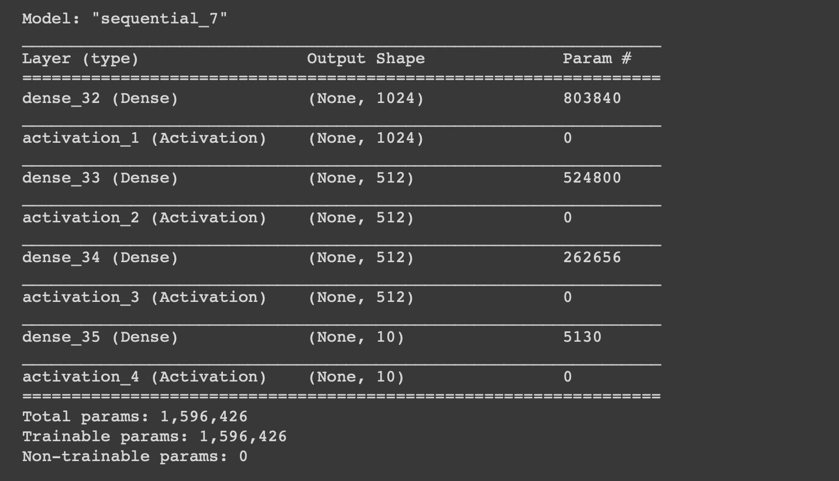

1. On the CIFAR10 dataset, the accuracy of the sequential model with 4 layers having 1024,512,512,10 nodes was 0.4979. However, after increasing the batch size to 1000, increasing the no. of epochs to 100, and changing no. of nodes in each layer, the accuracy became 0.5129. The accuracy plots are as follows:

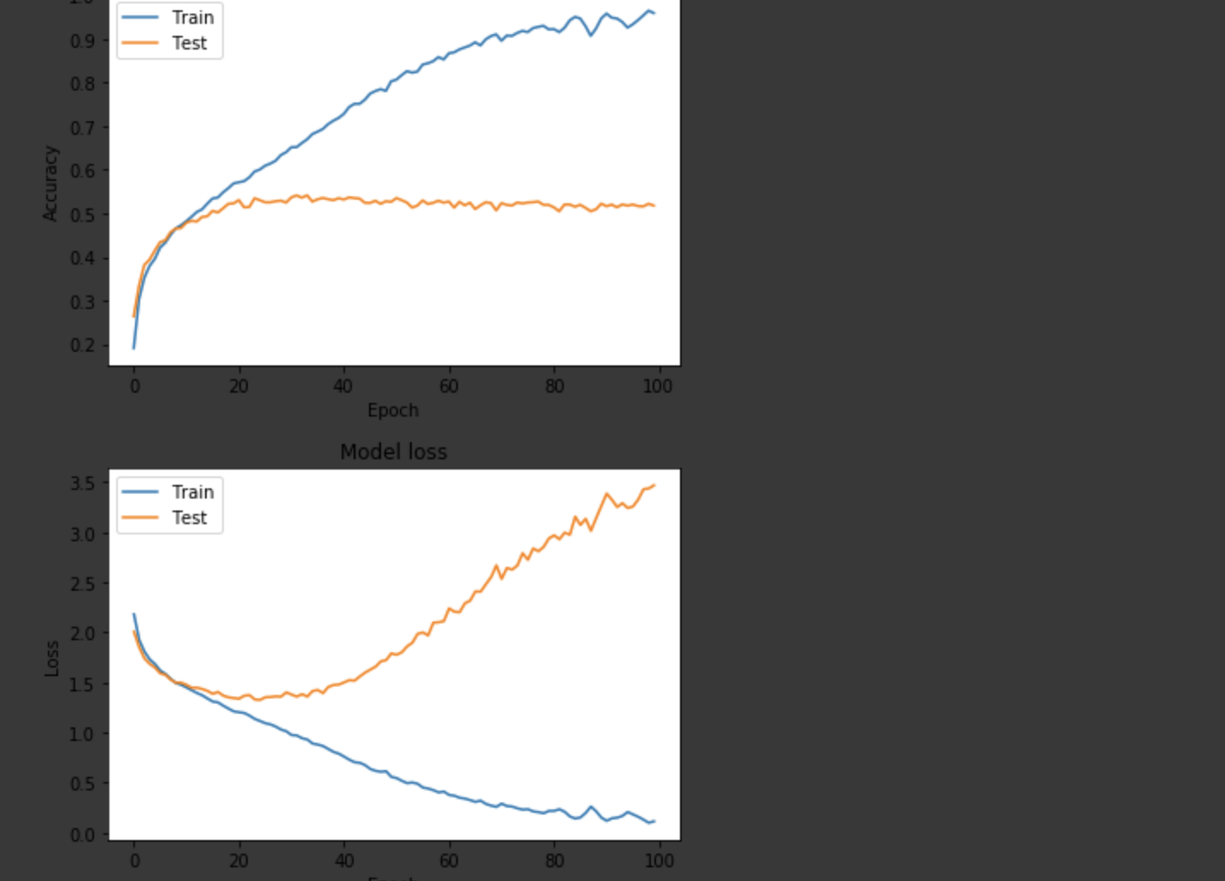

1. For the iris dataset, the sequential model consisted of 4 layers with 1024,512,512,3 nodes respectively. The accuracy was 1.

